Walkthrough 25 Sorting and Grouping

https://sapui5.hana.ondemand.com/#/topic/c4b2a32bb72f483faa173e890e48d812

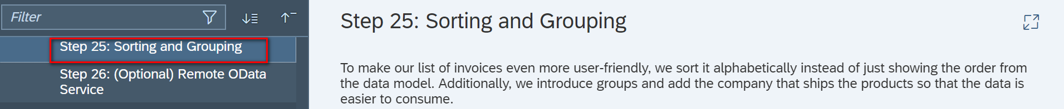

Core Changed Codes Compared to Last Version:

InvoiceList.view.xml:按照公司分组,产品升序排序

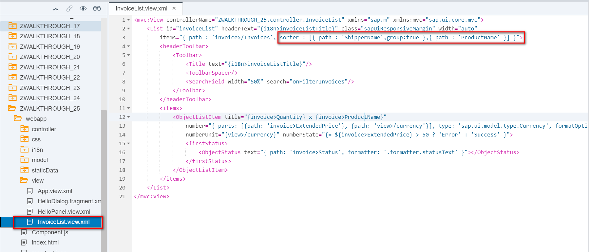

i18n 文本对象管理

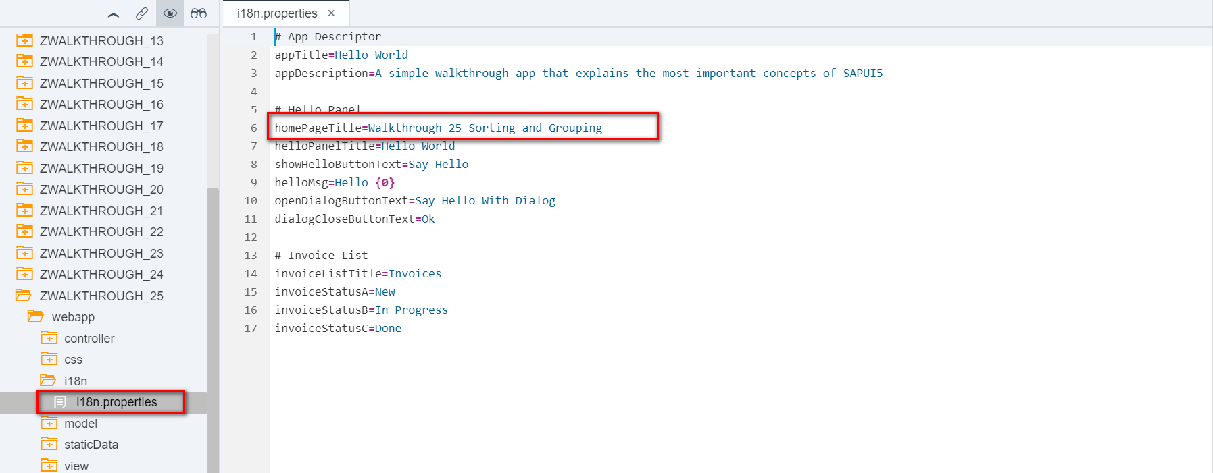

Result

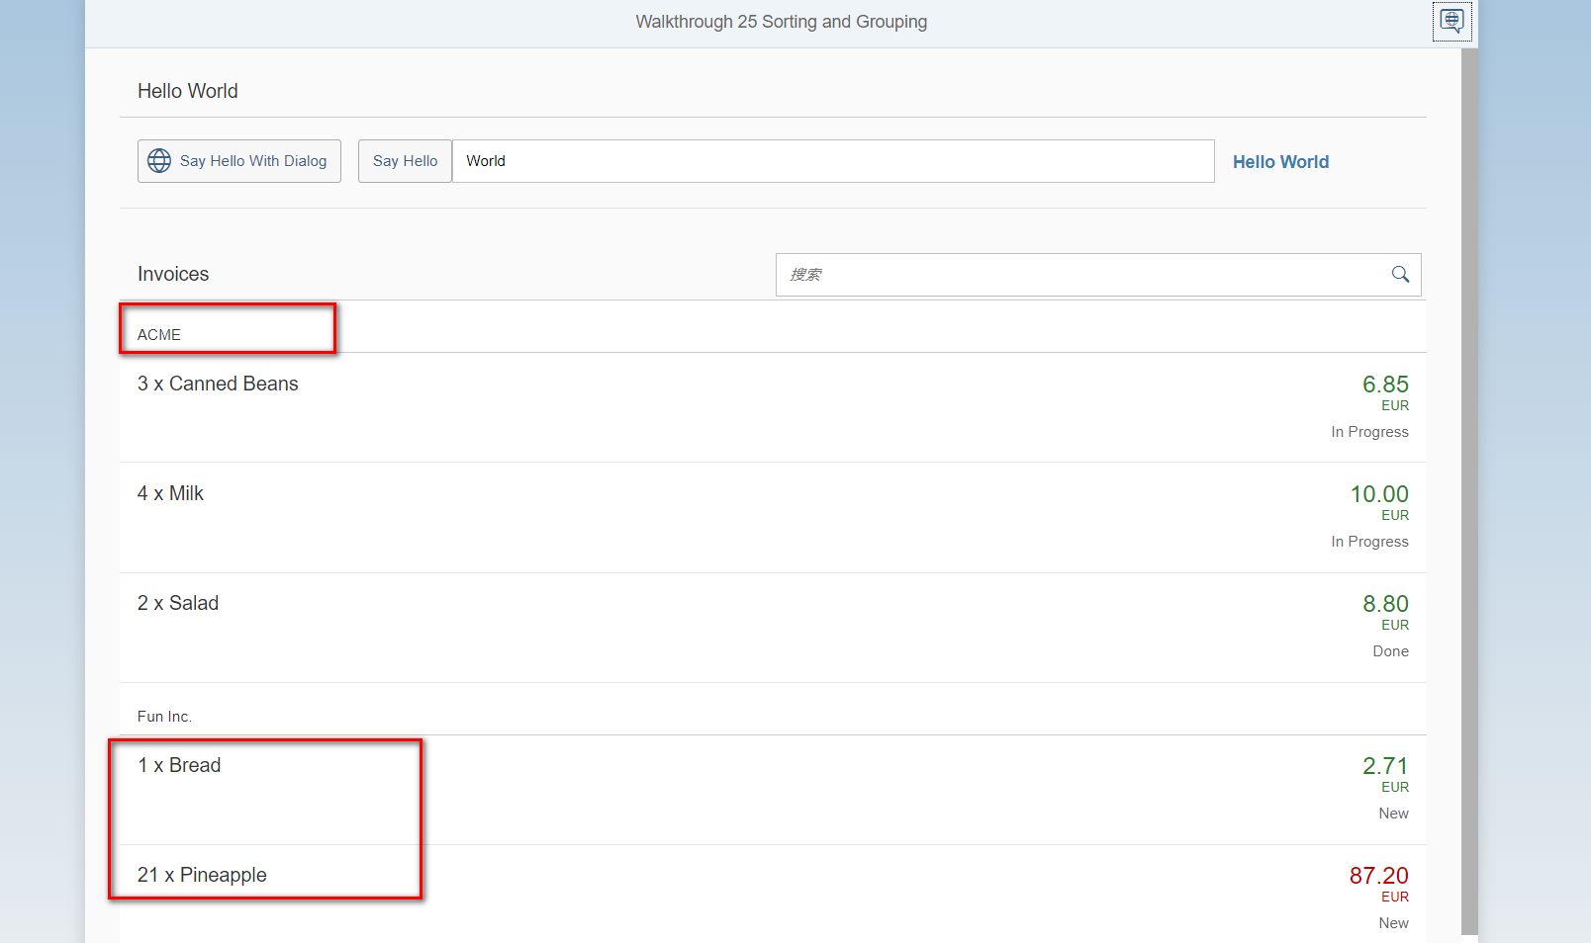

Git:

https://github.com/xiexiaop/SAPUI5-2-Round/tree/master/Projects/ZWALKTHROUGH_25

2019/02/04 XiaoMi Beijing Zac,Xie